**Powering System**

* <https://arduino.stackexchange.com/questions/22045/how-to-power-an-arduino-using-automated-mains-rechargeable-battery-switching>

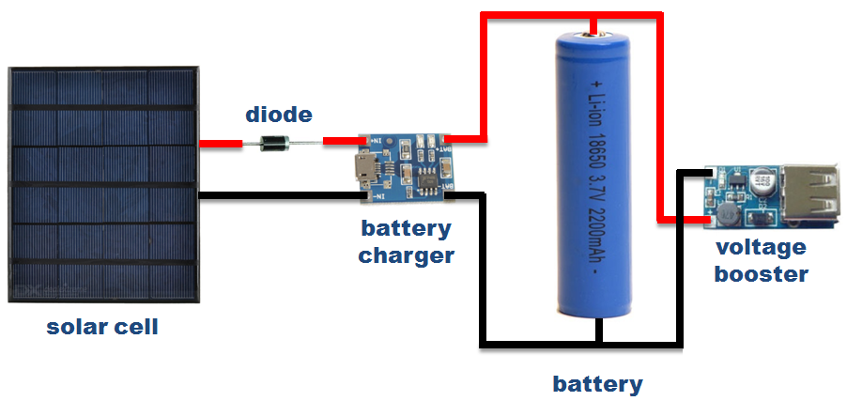

* <https://www.aliexpress.com/item/32895526166.html?spm=a2g0o.productlist.0.0.44da6c37020Mi0&algo_pvid=bdaeb020-67f1-4639-8cf8-87ccfb2b54fc&algo_expid=bdaeb020-67f1-4639-8cf8-87ccfb2b54fc-1&btsid=37f53508-e254-4399-b624-7db79c6d08dc&ws_ab_test=searchweb0_0,searchweb201602_1,searchweb201603_55>

**How to use multiple i2c devices on the same bus with the Arduino**

* <https://www.youtube.com/watch?v=nEySekIIxpw>